PowerSchool Students in Sections – DDE
Finding total number of students enrolled in each section – Use the following instructions to pull information from PowerSchool using DDE.

Instructions:
- On the PowerSchool start page, choose System from the main menu.
- Then choose Direct Database Export (DDE) from the list.
- For Current Table: choose Sections(3).
- Under Search Sections, filter the term ID = TermID
(the Term ID for Semester 2 2013-2014 is 2302).

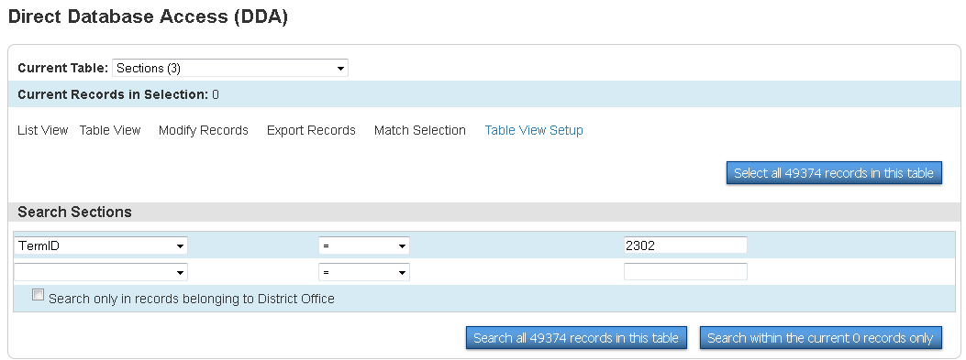

- Once you have all the above information in the screen, then Search all #### records in this table.

- If your search is successful, then you will notice the “0” in the Current Records in Selection change to the number of records you pulled in your search. Example below changed to 306 records found.

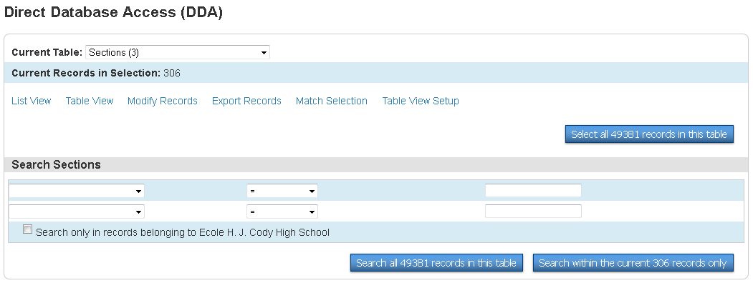

- Click - Export Records.

- On the next screen input the following information into the Field Delimiter area.
NOTE: instead of the table number you could use the table name if you would rather (must be the EXACT name of the table).
Ex: instead of [5] you could use [Teachers] or instead of [2] you could use [Courses]
Just remember that regardless of your preference above you must use the [ ] for either option.
No_Of_Student
Course_Number
[2]Course_Name
Section_Number
[5]LastFirst

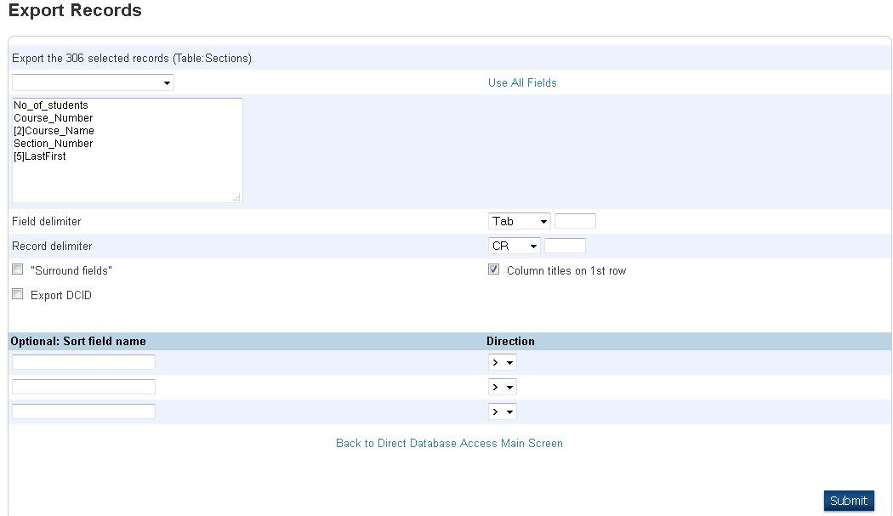

All of these fields can be found in this drop down menu, except for the ones pulling from other tables [ ], which will have to be typed in.

- Remember to click on SUBMIT.

- This information will now be pulled into EXCEL where it will be easy to see the number of students enrolled in each section.

